RESOLUTION NO.__________

RE: CERTIFICATE OF APPROPRIATENESS UNDER THE
PROVISIONS OF THE ACT OF THE PENNSYLVANIA
LEGISLATURE 1961, JUNE 13, P.L. 282 (53
SECTION 8004) AND BETHLEHEM ORDINANCE NO.
3952 AS AMENDED.

WHEREAS, it is proposed to install a sign at 805 E 4th St.

NOW, THEREFORE, BE IT RESOLVED by the Council of the City of Bethlehem that a Certificate of Appropriateness is hereby granted for the work.

Sponsored by: (s)

(s)

ADOPTED BY COUNCIL THIS DAY OF

(s)
President of Council

ATTEST:

(s)
City Clerk

HISTORIC CONSERVATION COMMISSION

CASE # 406 – It is proposed to install a 5’ x 4’ projecting sign at 805 E 4th St.
OWNER/APPLICANT: Jomar Holding Company, Inc/Rafael Munoz

The Commission upon motion by Mr. Cornish and seconded by Mr. Lader adopted the proposal that City Council issue a Certificate of Appropriateness for the proposed work described herein:

- The proposal to install a 5’ x 4’ projecting sign at 805 E 4th St. was presented by Rafael Munoz.

- The new sign will replace the sign faces in an existing box sign.

- The sign will read “Spanish American Food, Munoz Family Restaurant” and will be redesigned as discussed at the meeting and as sketched by the Historic Officer.

- The box sign will have no internal illumination.

- The phone number, “Dine-in or Take out”, and “Breakfast Lunch and Dinner” will be placed on the square window glass to the right of the door.

- The final design must be submitted to the City for final review and approval by the Historic Officer.

- It is recommended that the awning framework be removed and a letter will be sent to the building owner to have it removed.

- The proposed motion was unanimously approved.

CU: cu

By: 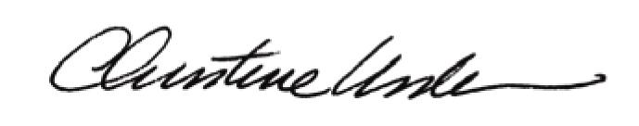

Date of Meeting: February 27, 2012 Title: Historic Officer

